

**American International University- Bangladesh (AIUB) Faculty of Engineering (EEE)**

**CO4: Implement electrical circuit (including DC, AC source, load and measuring equipment) in a group from the given schematics circuits and adapt with electrical measuring devices considering standards for professional engineering. (**P.e.2.P4), K6-P1,P4,P5

**Marking Rubrics (to be filled by Faculty)**

**Objectives**

**Unsatisfactory (0-1)**

**Good (2-3)**

**Excellent (4-5)**

**Marks**

**Performance (10)**

**Setup of experiment, Take proper measurements**

Cannot setup experiment without support

Cannot take measurements

Can setup some of the portions of

experiment without support Can take measurements but inaccurately

Can setup the whole

experiment without support

Can take organized and

accurate measurements

**Identify experiment goals, Summarize findings and compare actual to expected results**

Cannot identify goals

Cannot summarize or compare findings

to expected results

Can identify some goals but unable to draw adequate hypothesis

Summarize finding in an

incomplete way

Can identify necessary and sufficient goals

Summarize finding in a complete way

**Report (10)**

**Observation 1**

Cannot answer any question related to the

experimental setup

Can answer some of the questions

Can answer most or all the

questions

**Observation 2**

Unexpected experimental outcome between calculated data

and experimented data

Somewhat unexpected experiment

outcome

Accurate data collected from the hardware

**Comments**

Assessed by (Name, Sign, and Date)

Total (out of 10):

**Group Members**

**ID**

**Name**

1.

2.

3.

4.

5.

**Student Name:**

**Student ID:**

**Task:**

Perform Open End Lab following given instructions.

**Experiment title:**

**Course Name:**

Introduction to Electrical Circuits (IEC) Lab

**Course Code:**

COE 2102

**Semester:**

Fall 2023-24

**Sec:**

All

**Faculty:**



**American International University- Bangladesh (AIUB) Faculty of Engineering (EEE)**

**CO4: Implement electrical circuit (including DC, AC source, load and measuring equipment) in a group from the given schematics circuits and adapt with electrical measuring devices considering standards for professional engineering. (**P.e.2.P4), K6-P1,P4,P5

**Marking Rubrics (to be filled by Faculty)**

**Objectives**

**Unsatisfactory (0-1)**

**Good (2-3)**

**Excellent (4-5)**

**Marks**

**Performance (10)**

**Setup of experiment, Take proper measurements**

Cannot setup experiment without support

Cannot take measurements

Can setup some of the portions of

experiment without support Can take measurements but inaccurately

Can setup the whole

experiment without support

Can take organized and

accurate measurements

**Identify experiment goals, Summarize findings and compare actual to expected results**

Cannot identify goals

Cannot summarize or compare findings

to expected results

Can identify some goals but unable to draw adequate hypothesis

Summarize finding in an

incomplete way

Can identify necessary and sufficient goals

Summarize finding in a complete way

**Report (10)**

**Observation 1**

Cannot answer any question related to the

experimental setup

Can answer some of the questions

Can answer most or all the

questions

**Observation 2**

Unexpected experimental outcome between calculated data

and experimented data

Somewhat unexpected experiment

outcome

Accurate data collected from the hardware

**Comments**

Assessed by (Name, Sign, and Date)

Total (out of 10):

**Group Members**

**ID**

**Name**

1.

22-48065-2

MD. Abdullah

2.

22-47981-2

Azmir Islam Kafi

3.

22-47975-2

Mohammad Ansar Uddin

4.

22-48056-2

Chinmoy Guha

5.

22-48067-2

Suvra Chakraborty

**Student Name:**

Chinmoy Guha

**Student ID:**

22-48056-2

**Task:**

Perform Open End Lab following given instructions.

**Experiment title:**

**Course Name:**

Introduction to Electrical Circuits (IEC) Lab

**Course Code:**

COE 2102

**Semester:**

Fall 2023-24

**Sec:L**

All

**Faculty:**

Md. Shahariar Parvez

Construct an R-L-C circuit with a series parallel combination and apply KCL and KVL in AC and analyze behavior of it.



**AMERICAN INTERNATIONAL UNIVERSITY- BANGLADESH**

**(AIUB)**

**Introduction to Electrical Circuit**

**FALL 2023-2024**

**Section: L, Group: 07**

**LAB REPORT ON**

***Construct an R-L-C circuit with a series parallel combination and apply KCL and KVL in AC and analyze the behavior of the circuit through data obtained during Laboratory work***

**Supervised By**

**MD. SHAHARIAR PARVEZ**

|  |  |
| --- | --- |
| **Name** | **ID** |
| **1.MD. Abdullah** | **22-48065-2** |
| **2.Azmir Islam Kafi** | **22-47981-2** |
| **3.Mohammad Ansar Uddin** | **22-47975-2** |
| **4.Chinmoy Guha** | **22-48056-2** |
| **5.Suvra Chakraborty** | **22-48067-2** |

***Abstract:***

The purpose of the experiment was to construct an RLC circuit in a series parallel combination using laboratory knowledge previously gained and verify KCL and KVL in them. The circuit designed had at least two branches that are in parallel. Each inductor and capacitor had at least one resistor in series with it and there were 4 resistors in total.

***Circuit diagram:***

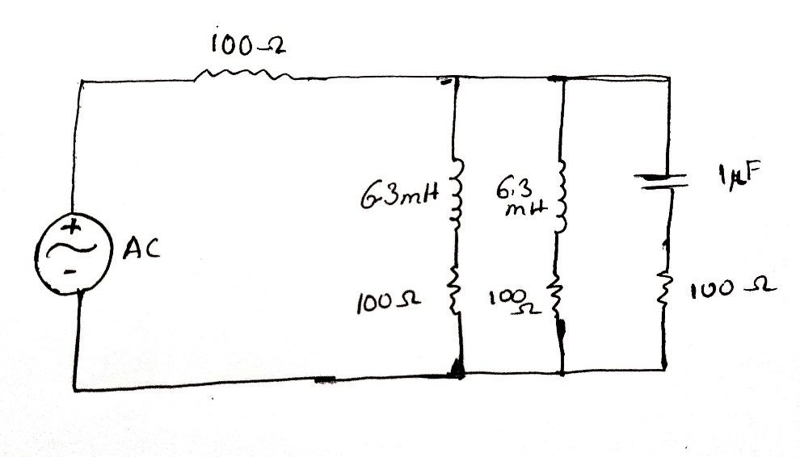

***Figure 1: Series-Parallel combination circuit.***

**Apparatus:**

1. Oscilloscope, b) Function generator c) Resistor: 100 ohm - 4 pcs d) 2 Inductors: 6.3 mH e) Capacitor: 1 microF f) Connecting wire, g) Bread board f) PC

***Experimental Procedure:***

KCL:  
The circuit shown in Figure 1 was successfully constructed, with channel 1 of the oscilloscope connected across the function generator and channel 2 across RL. We set the amplitude of the input signal to 5V peak, adjusted the frequency to 1 kHz, and selected a sinusoidal wave shape. The values of VRL and IL were measured, and the phase relationship (θL) between E and VRL was determined. Same was done for the 2nd inductor. Then, channel 2 of the oscilloscope was then connected across RC, and measurements for VRC and IC were taken. The phase relationship (θC) between E and VRC was determined. Phasors IL and IC were added, and subsequently, channel 2 of the oscilloscope was connected across R to measure VR and IR. The phase relationship (θ) between E and VR was determined. The theoretical sum of IL and IC was compared with the practically obtained value of IR.

KVL:

Channel 1 of the oscilloscope was connected across the AC voltage source, and channel 2 was linked across R.

The amplitude of the input signal was set to 5V peak.

The frequency of the signal generator was adjusted to 1 kHz, and a sinusoidal wave shape was selected.

The phase relationship (θ) between the waves was determined.

The value of current (I) was measured.

Measurements were taken for the values of VR, VRL1, VRL2 and VRC.

Kirchhoff's Voltage Law (KVL) was verified using the experimental data

***Result analysis :***

**Data Table:**

|  |  |  |  |  |  |  |  |  |  |
| --- | --- | --- | --- | --- | --- | --- | --- | --- | --- |
| f | Vrl1 | Vrl2 | Il1&2 | Vrc | Ic | IL1+IL2+Ic | Vr | Is | Vrms |
| 1KHz | 1.18 ∠4.430 | 1.18 ∠4.430 | 0.011∠-17.170 | 1.14∠4.430 | 0.0006044∠62.330 | 0.024∠-2.980 | 3.432V | 0.023∠-2.20 | 3.535V |

***Simulation:  
  
TABLE:***

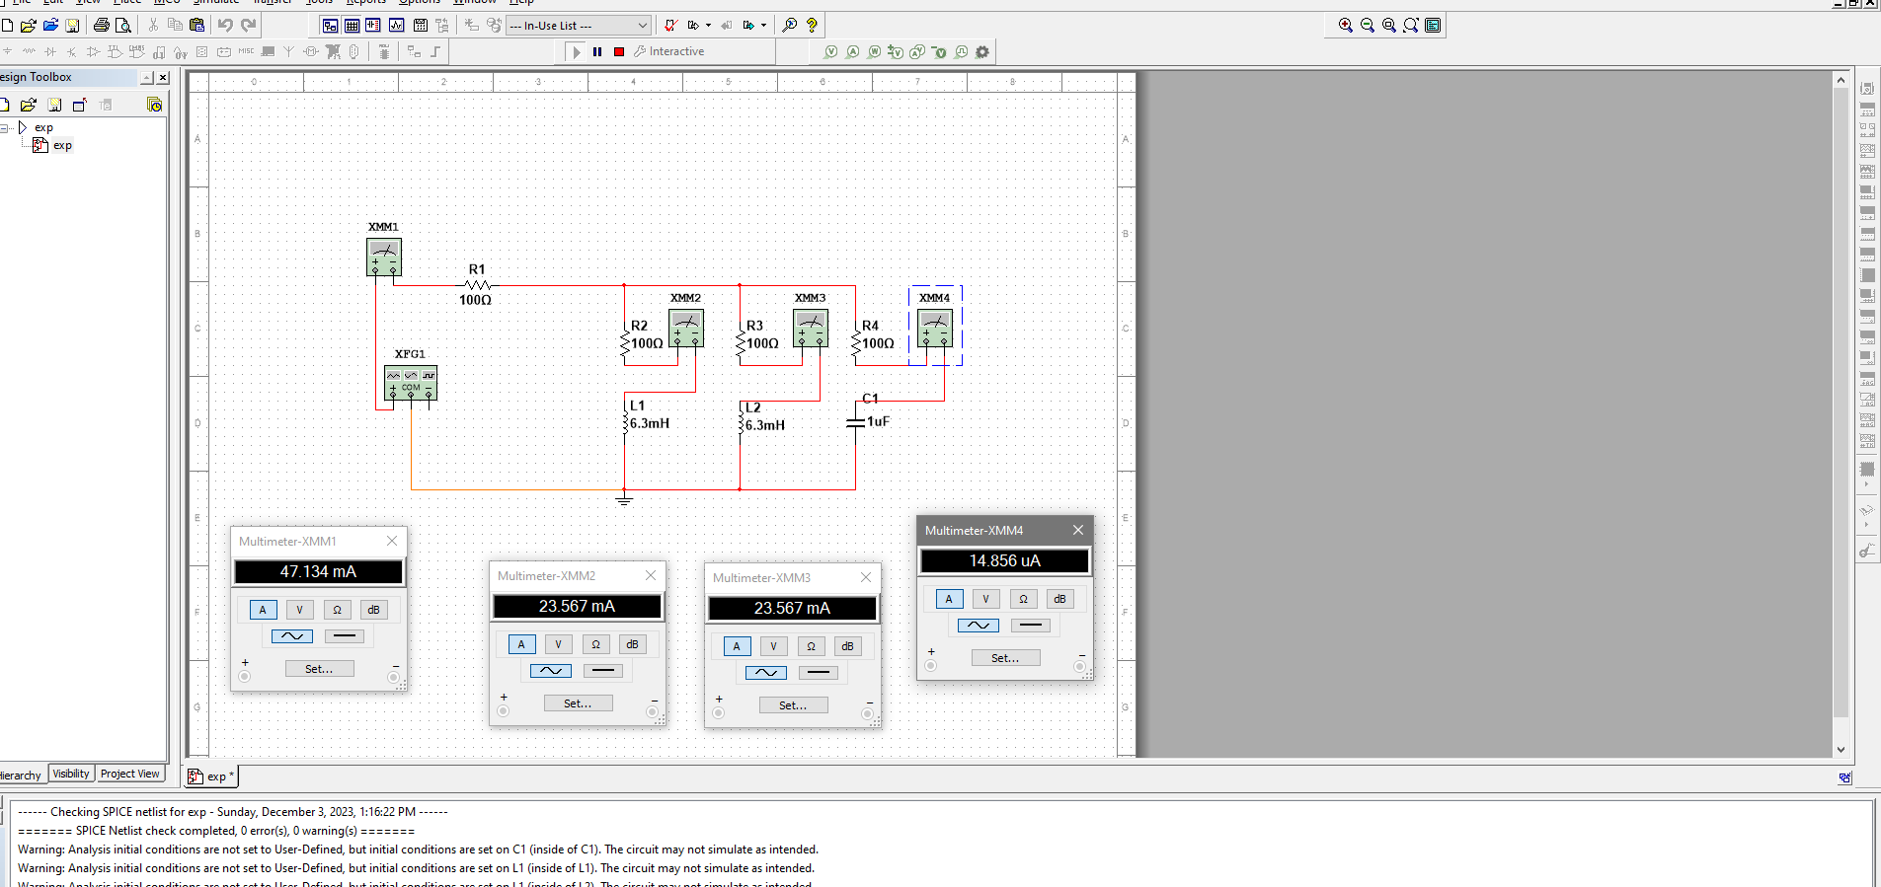

***Figure: KCL***

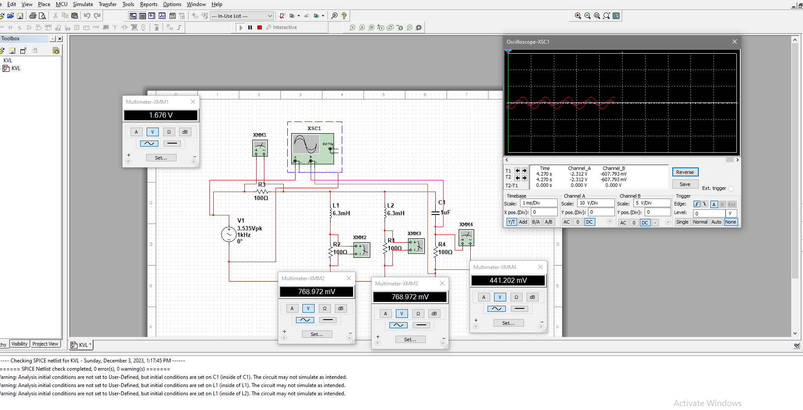

***Figure: KVL***

***Calculation:***

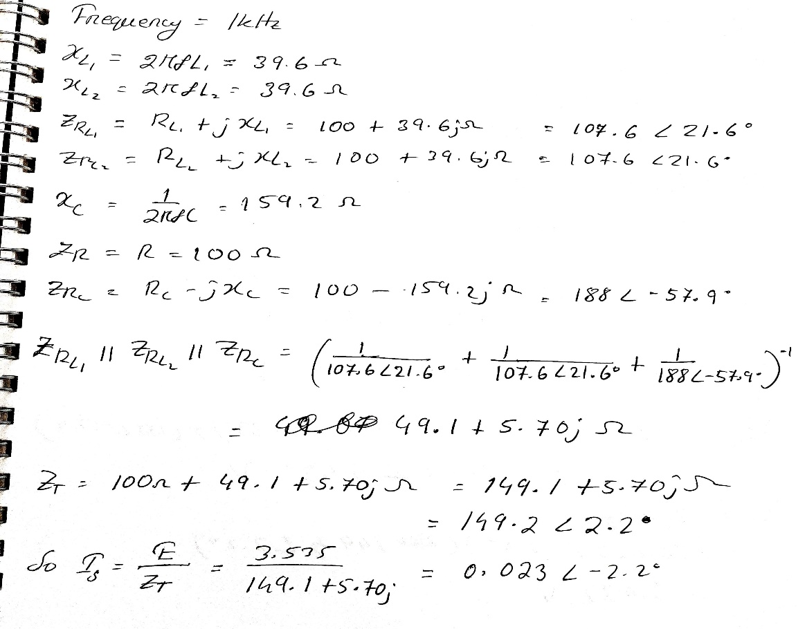

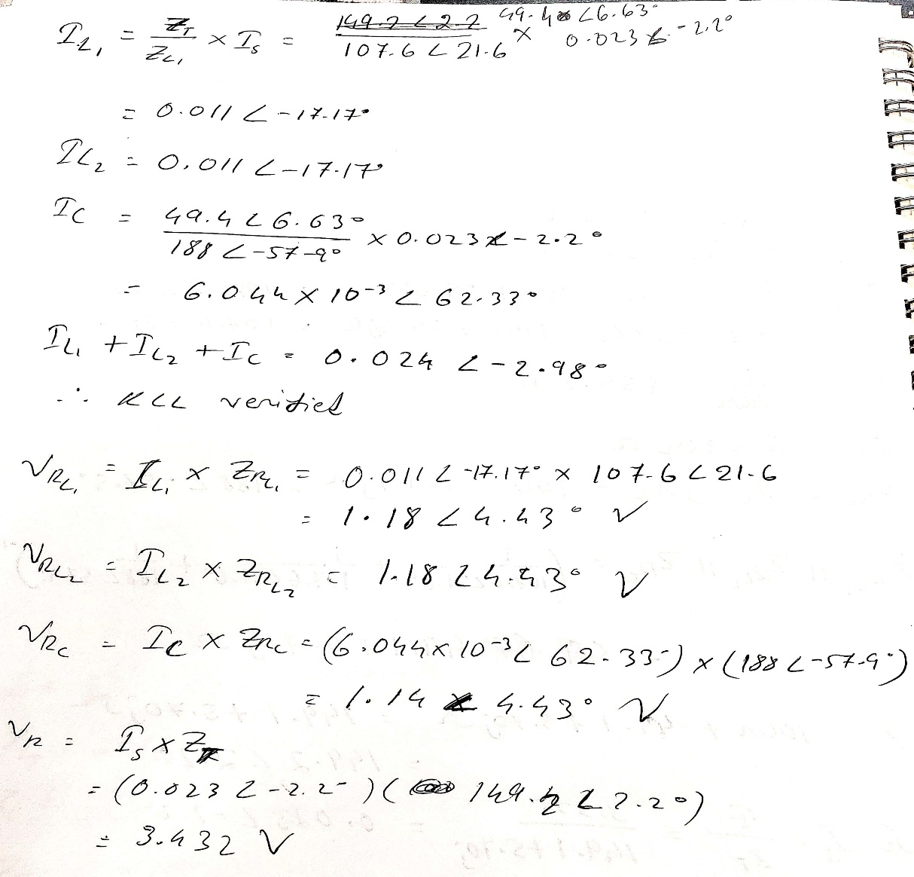

***Discussion***

If we apply KCL,

I = IL1 + IL2 + IC

This condition must be true. But there might be some mismatch of the measured value with the

theoretical value because we are taking the value as fraction. If we take all the values from the

fractional part, results must be equal. When we are taking the values from the waveforms,

approximate data are taken so there might be some error too.

In this experiment, we got a value which was very close to our expected value.

For KVL, the source voltage must be equal to the voltage drops across all the nodes which is also approximately similar in our experiment. Therefore

***Conclusion:***

By completing this experiment we successfully measured RLC series-parallel circuits and we verified KCL and KVL in it.